Bahria University,

Karachi Campus

LAB EXPERIMENT NO.

**4**

LIST OF TASKS

|  |  |
| --- | --- |
| TASK NO | OBJECTIVE |
| **1** | Develop an employee profile within the MVC .NET web application. Design a user interface that allows users to view, create, update, and delete employee records using ADO .Net Entity Framework. |
| 2 | Implement a product catalog in the MVC .NET web application utilizing ADO.NET Entity Framework. Design a user interface that enables users to browse, add, modify, and remove product records |

Submitted On:

4 April 2024

____________

(Date: DD/MM/YY)

**Task 1**

Develop an employee profile within the MVC .NET web application. Design a user interface that allows users to view, create, update, and delete employee records using ADO .Net Entity Framework.

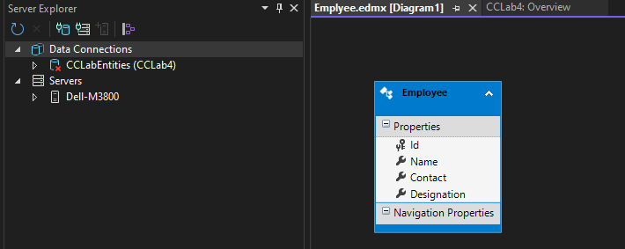

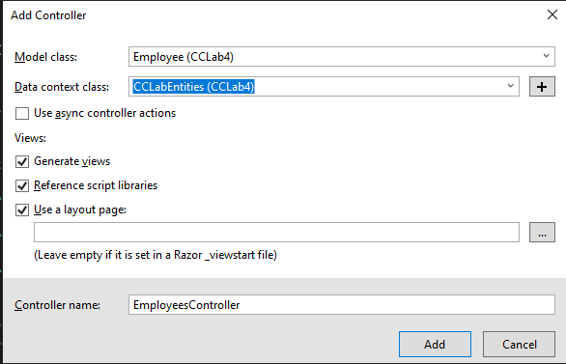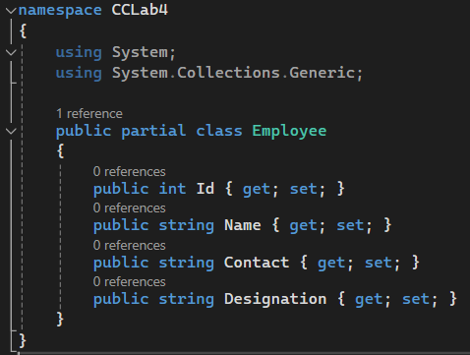

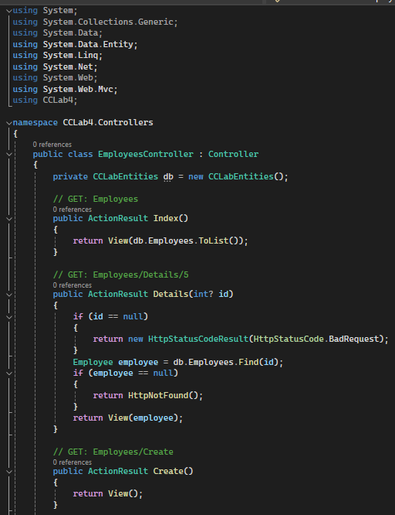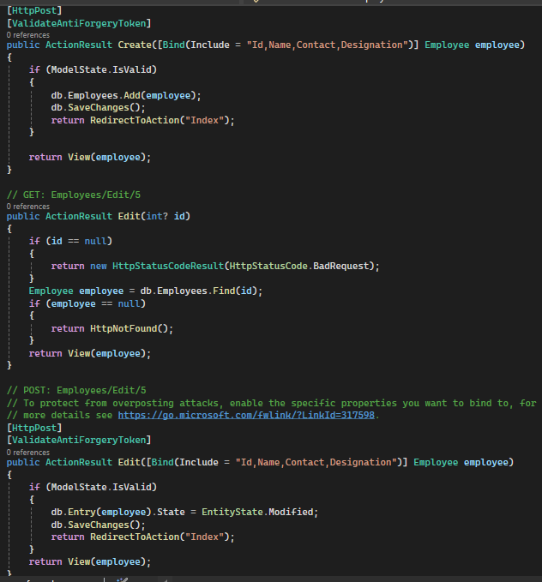

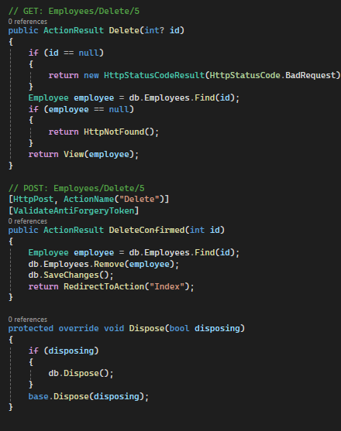

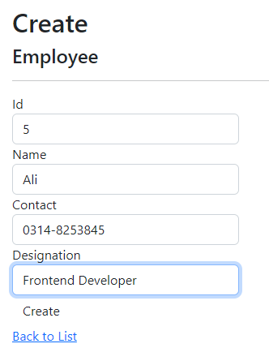 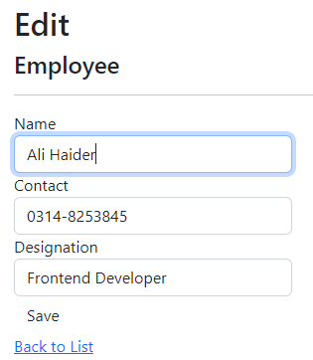

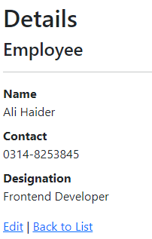 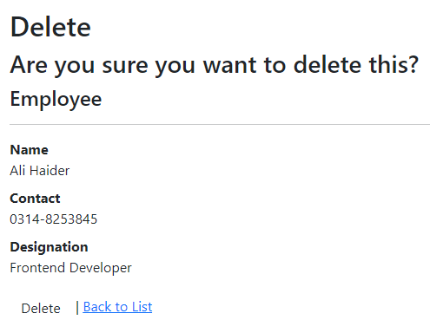

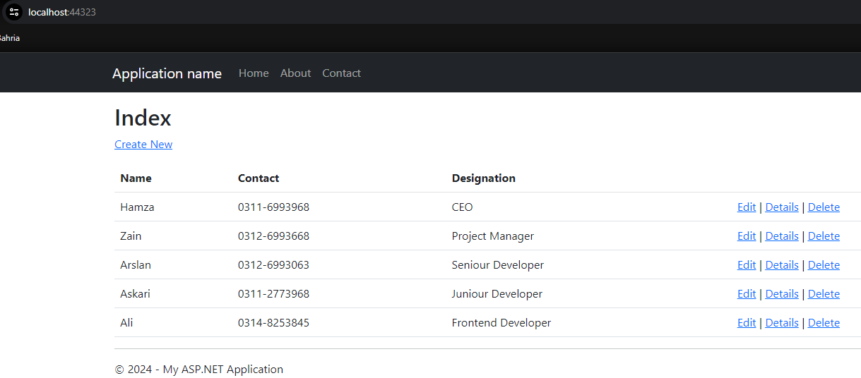

**Task 2**

Implement a product catalog in the MVC .NET web application utilizing ADO.NET Entity Framework. Design a user interface that enables users to browse, add, modify, and remove product records

